Java Portfolio for my project “bday”.
Date: May 22, 2023
What is it: I wrote a program that’s used to find the day according to the given date and is able to identify if the year is a leap year .

Source code: bday.java
import java.util.Scanner;
import java.time.LocalDate;
public class bday{
public static void main(String[]args){

String status;
Scanner input=new Scanner(System.in);
System.out.println("Please input the year that you were born: ");
int year=input.nextInt();
System.out.println("Please input the month that you were born: ");
int month=input.nextInt();
System.out.println("Please input the day that you were born: ");
int day=input.nextInt();
while(month>0 && year>0 && day>0){

if ((year%4==0 && year%100!=0) || year%400==0){
status="leap year";
}
else
status="common year";

LocalDate localDate = LocalDate.of(year, month, day);
java.time.DayOfWeek dayOfWeek = localDate.getDayOfWeek();
System.out.println("Day of week in number:"+dayOfWeek.getValue());
System.out.println("Day of week in text:"+dayOfWeek.toString());
System.out.println("The year you were born was a "+status+".");

break;
}//while

}//main
}//class
How it goes:

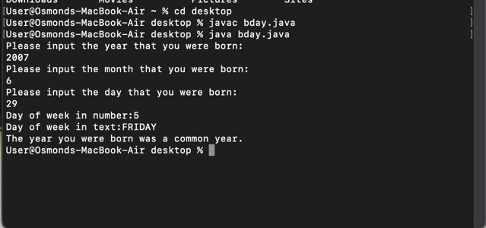
What I have learned:
- Import java.time.LocalDate to actually get the access with the calendar and in turn know the date.
- Knowing how to use while loop as an infinite loop.

